Drive already mounted at /content/drive; to attempt to forcibly remount, call drive.mount("/content/drive", force_remount=True).

Found 9027 images belonging to 9 classes.

Found 2252 images belonging to 9 classes.

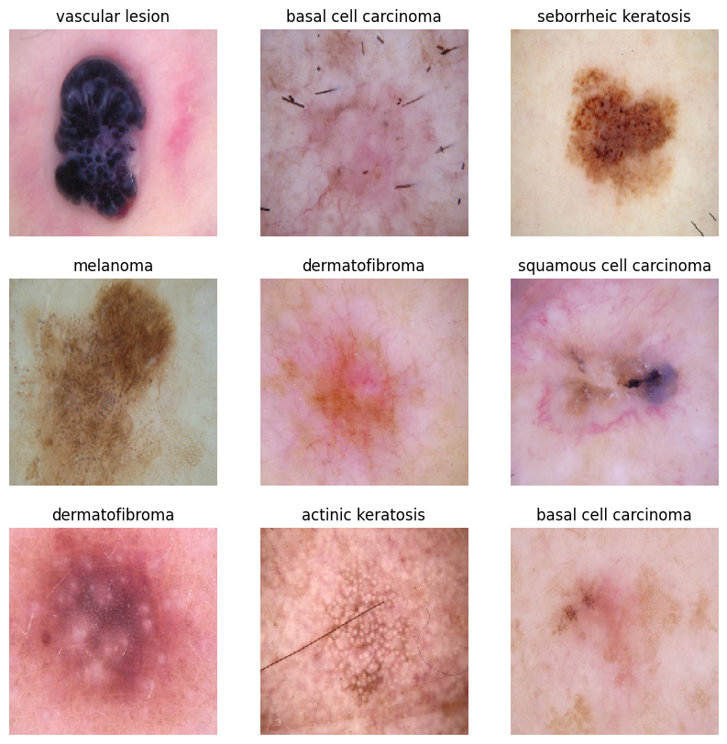

Processing class: /content/drive/MyDrive/Cancer_Dataset/train/actinic keratosis

Initialised with 114 image(s) found.

Output directory set to /content/drive/MyDrive/Cancer_Dataset/train/actinic keratosis/output.

Processing <PIL.Image.Image image mode=RGB size=600x450 at 0x7A6B26ED3280>: 100%|██████████| 1000/1000 [01:10<00:00, 14.20 Samples/s]

Processing class: /content/drive/MyDrive/Cancer_Dataset/train/basal cell carcinoma

Initialised with 376 image(s) found.

Output directory set to /content/drive/MyDrive/Cancer_Dataset/train/basal cell carcinoma/output.

Processing <PIL.Image.Image image mode=RGB size=600x450 at 0x7A6A9C77D6C0>: 100%|██████████| 1000/1000 [01:07<00:00, 14.87 Samples/s]

Processing class: /content/drive/MyDrive/Cancer_Dataset/train/dermatofibroma

Initialised with 95 image(s) found.

Output directory set to /content/drive/MyDrive/Cancer_Dataset/train/dermatofibroma/output.

Processing <PIL.Image.Image image mode=RGB size=600x450 at 0x7A6AA0435870>: 100%|██████████| 1000/1000 [01:07<00:00, 14.88 Samples/s]

Processing class: /content/drive/MyDrive/Cancer_Dataset/train/melanoma

Initialised with 438 image(s) found.

Output directory set to /content/drive/MyDrive/Cancer_Dataset/train/melanoma/output.

Processing <PIL.Image.Image image mode=RGB size=962x645 at 0x7A6A9C432980>: 100%|██████████| 1000/1000 [04:14<00:00, 3.93 Samples/s]

Processing class: /content/drive/MyDrive/Cancer_Dataset/train/nevus

Initialised with 377 image(s) found.

Output directory set to /content/drive/MyDrive/Cancer_Dataset/train/nevus/output.

Processing <PIL.Image.Image image mode=RGB size=767x576 at 0x7A6A9C524C10>: 100%|██████████| 1000/1000 [03:59<00:00, 4.17 Samples/s]

Processing class: /content/drive/MyDrive/Cancer_Dataset/train/pigmented benign keratosis

Initialised with 482 image(s) found.

Output directory set to /content/drive/MyDrive/Cancer_Dataset/train/pigmented benign keratosis/output.

Processing <PIL.Image.Image image mode=RGB size=600x450 at 0x7A6A9E803B20>: 100%|██████████| 1000/1000 [01:09<00:00, 14.33 Samples/s]

Processing class: /content/drive/MyDrive/Cancer_Dataset/train/seborrheic keratosis

Initialised with 77 image(s) found.

Output directory set to /content/drive/MyDrive/Cancer_Dataset/train/seborrheic keratosis/output.

Processing <PIL.Image.Image image mode=RGB size=1024x768 at 0x7A6A9C6698D0>: 100%|██████████| 1000/1000 [02:05<00:00, 7.94 Samples/s]

Processing class: /content/drive/MyDrive/Cancer_Dataset/train/squamous cell carcinoma

Initialised with 181 image(s) found.

Output directory set to /content/drive/MyDrive/Cancer_Dataset/train/squamous cell carcinoma/output.

Processing <PIL.Image.Image image mode=RGB size=600x450 at 0x7A6A9E4ED120>: 100%|██████████| 1000/1000 [01:13<00:00, 13.60 Samples/s]

Processing class: /content/drive/MyDrive/Cancer_Dataset/train/vascular lesion

Initialised with 139 image(s) found.

Output directory set to /content/drive/MyDrive/Cancer_Dataset/train/vascular lesion/output.

Processing <PIL.Image.Image image mode=RGB size=600x450 at 0x7A6B26FC6950>: 100%|██████████| 1000/1000 [01:10<00:00, 14.15 Samples/s]

Epoch 1/2

**283/283** ━━━━━━━━━━━━━━━━━━━━ **814s** 3s/step - accuracy: 0.2276 - loss: 2.0655 - val_accuracy: 0.3845 - val_loss: 1.5772

Epoch 2/2

**283/283** ━━━━━━━━━━━━━━━━━━━━ **850s** 3s/step - accuracy: 0.3831 - loss: 1.5749 - val_accuracy: 0.4547 - val_loss: 1.4011

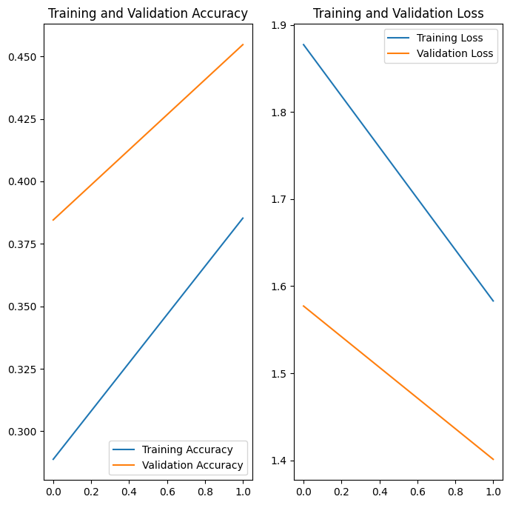

Found 16227 images belonging to 9 classes.

Epoch 1/2

/usr/local/lib/python3.10/dist-packages/keras/src/trainers/data_adapters/py_dataset_adapter.py:121: UserWarning: Your `PyDataset` class should call `super().__init__(**kwargs)` in its constructor. `**kwargs` can include `workers`, `use_multiprocessing`, `max_queue_size`. Do not pass these arguments to `fit()`, as they will be ignored.

self._warn_if_super_not_called()

**508/508** ━━━━━━━━━━━━━━━━━━━━ **1556s** 3s/step - accuracy: 0.3797 - loss: 1.5673 - val_accuracy: 0.5000 - val_loss: 1.3800

Epoch 2/2

**508/508** ━━━━━━━━━━━━━━━━━━━━ **1532s** 3s/step - accuracy: 0.4074 - loss: 1.5115 - val_accuracy: 0.4423 - val_loss: 1.4237

Found 16227 images belonging to 9 classes.

Epoch 1/3

**508/508** ━━━━━━━━━━━━━━━━━━━━ **1422s** 3s/step - accuracy: 0.4541 - loss: 1.3824 - val_accuracy: 0.4116 - val_loss: 1.6652

Epoch 2/3

**508/508** ━━━━━━━━━━━━━━━━━━━━ **1440s** 3s/step - accuracy: 0.4739 - loss: 1.3509 - val_accuracy: 0.5084 - val_loss: 1.2103

Epoch 3/3

**508/508** ━━━━━━━━━━━━━━━━━━━━ **1392s** 3s/step - accuracy: 0.5026 - loss: 1.2901 - val_accuracy: 0.5404 - val_loss: 1.1604